IOT Energy Meter with Current, Voltage and Cost Monitoring System

Observing and monitoring your power utilization for verification is a not a easy task today since regularly checking the meter room is very tedious task Well, it is very important to know whether you are charged likewise so the need is very sure.
Well, we have made a system that allows users to monitor energy meter readings over IOT. Our proposed system utilizes energy meter with microcontroller system to monitor energy utilization utilizing a meter.
The meter is used to monitor units consumed, estimated cost, Line Voltage and current consumed. Simple web application named IoT Gecko shows the Live Output of these reading over the IOT
This enables user to effortlessly check the units consumed, estimated cost, Line Voltage and current consumed Live from anywhere through the site. In this way the energy meter observing framework enables client to adequately screen power meter readings and check the charging on the IoTgecko.com effortlessly.

Block Diagram:
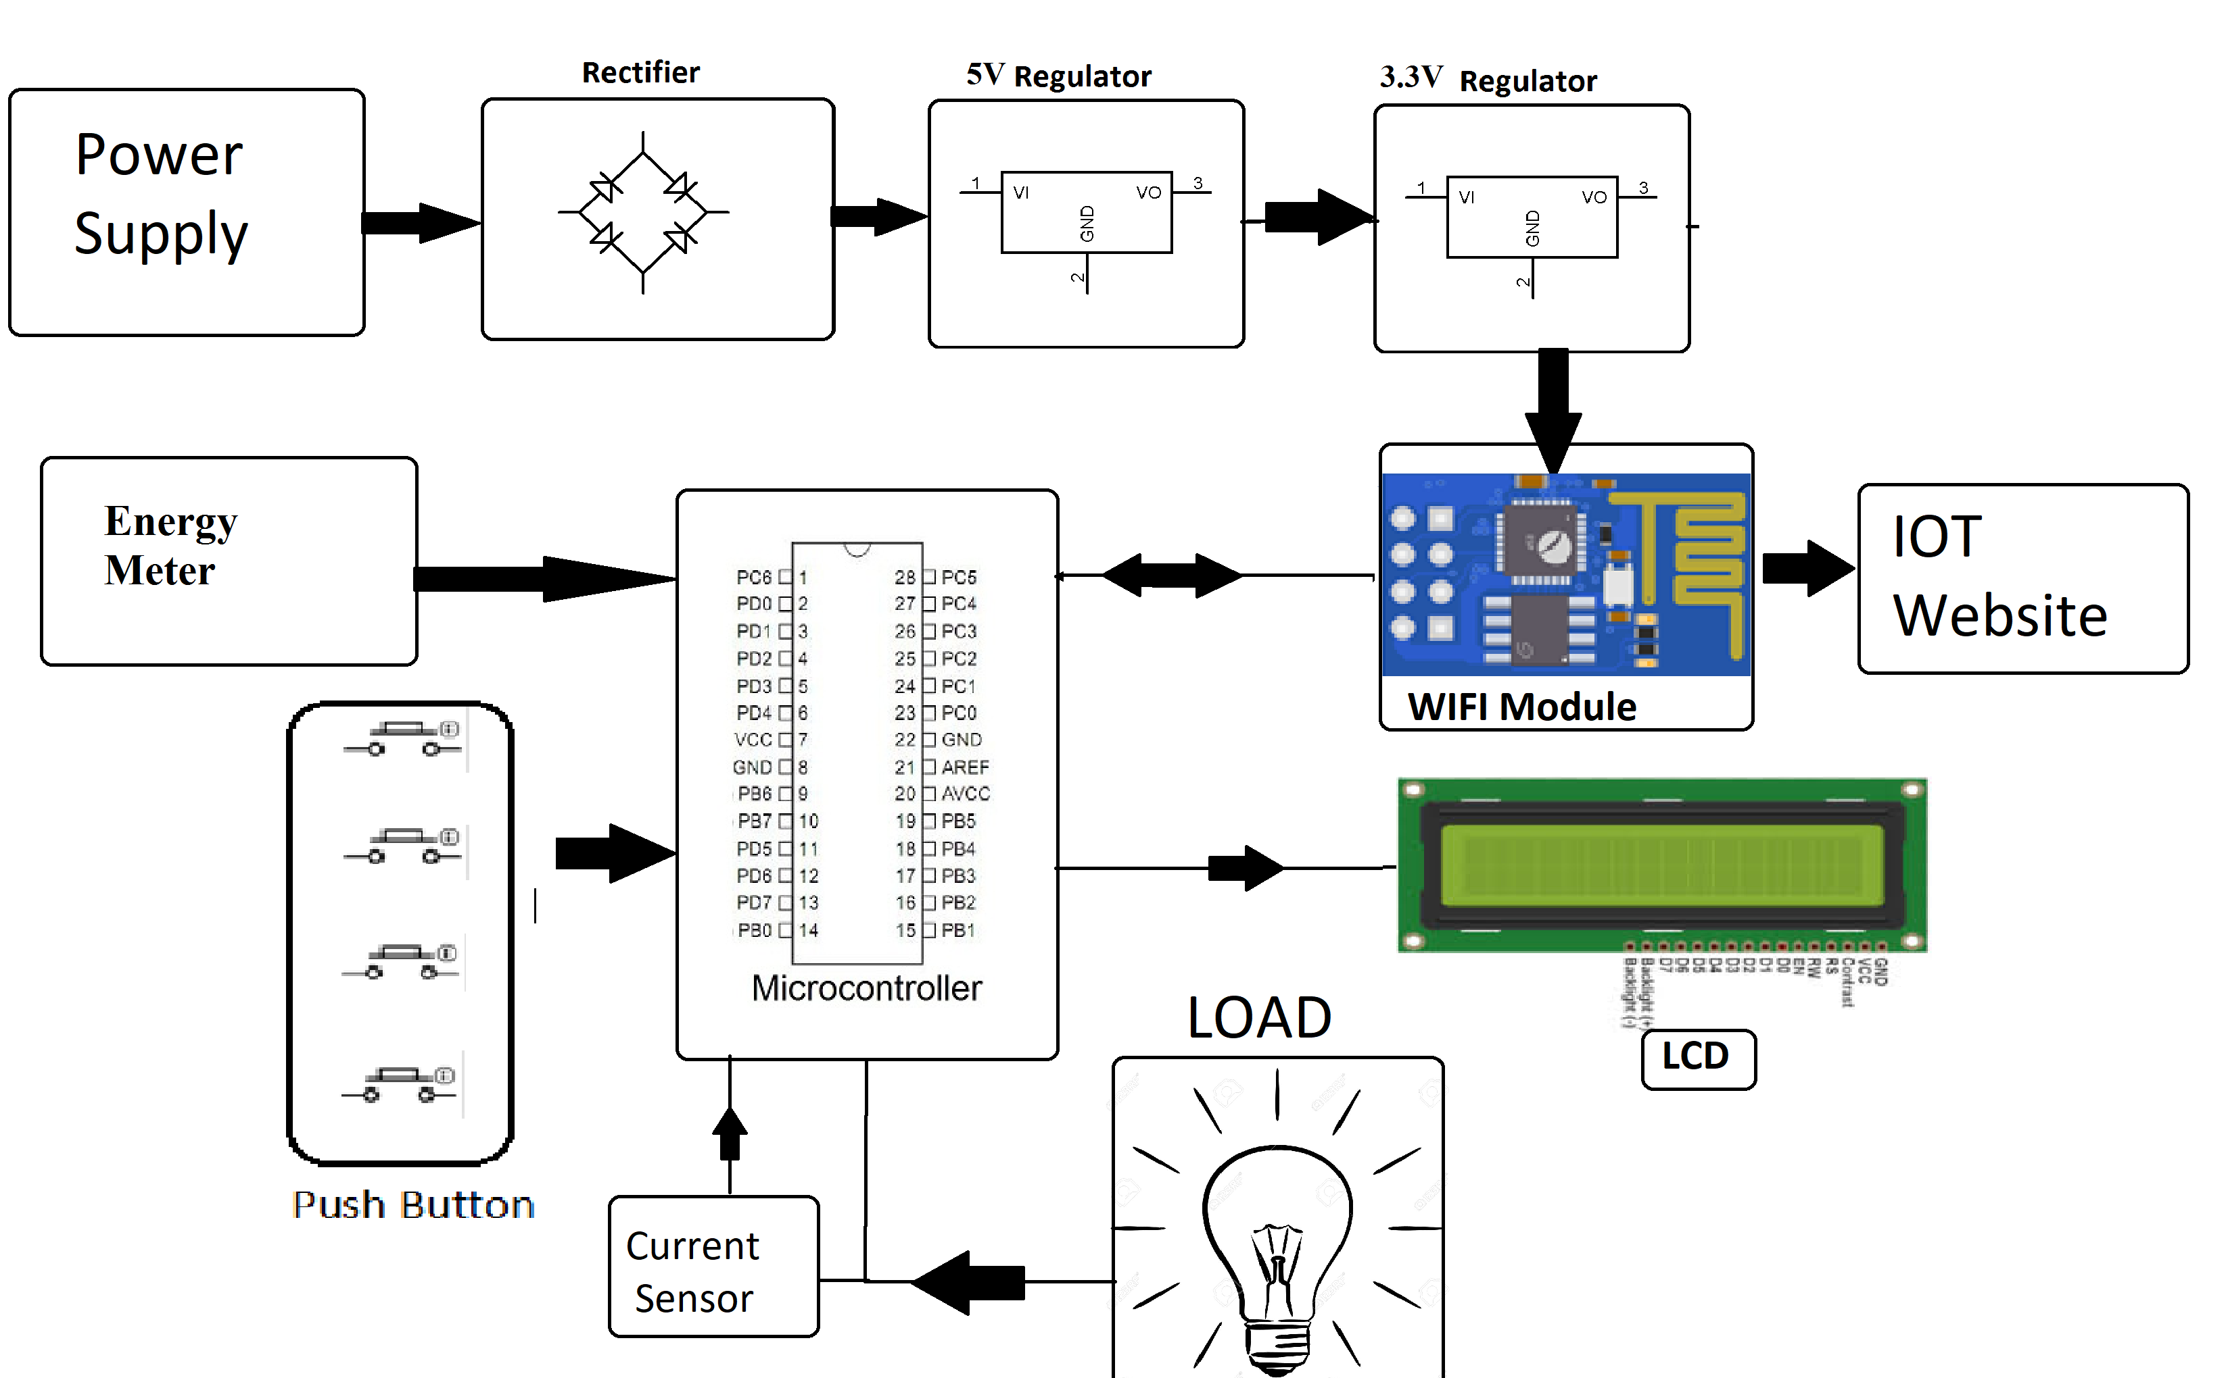

Hardware Specifications :
- Energy Meter
- WIFI Module
- Current Sensor
- Atmega 328 Microcontroller
- Wifi Modem
- LCD Display
- LED’s
- Transformer
- Resistors
- Capacitors
- Diodes

Software Specifications :
- Arduino Compiler
- MC Programming Language: C

Reference
- http://ieeexplore.ieee.org/xpl/articleDetails.jsp?arnumber=7300834&queryText=meter%20iot&newsearch=true

- http://ieeexplore.ieee.org/xpl/articleDetails.jsp?arnumber=6804465&queryText=meter%20iot&newsearch=true

